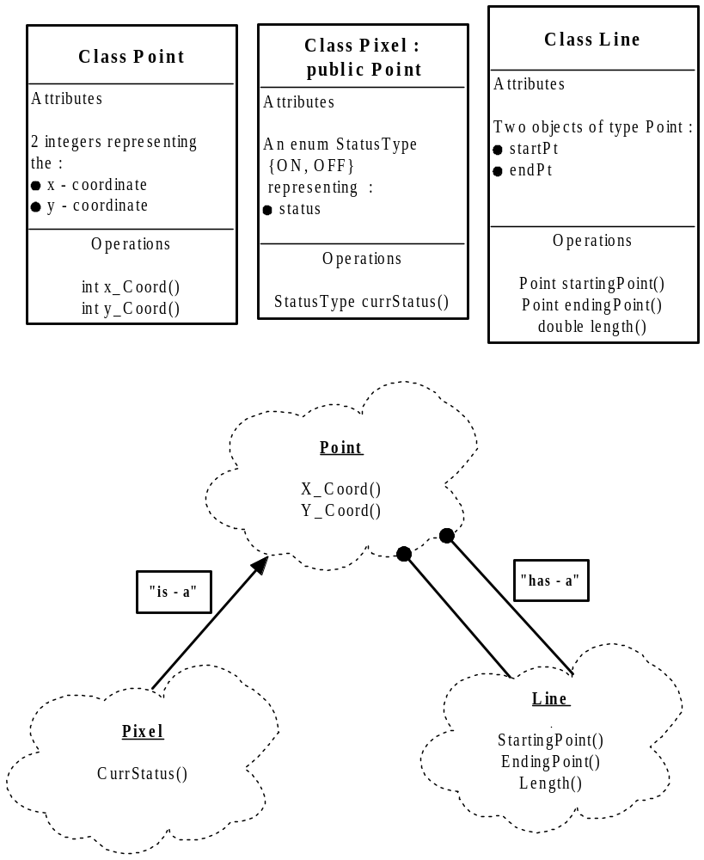
Using Rumbaugh Notation (visual ADTs with a listing of the data type, domain (attributes), and operations) and Booch Notation (cloud-like shapes showing all classes used by software and any relationships that exist between those classes) in the OOP design process.
OOP Analysis & Design Drawings from the Smartdraw software

